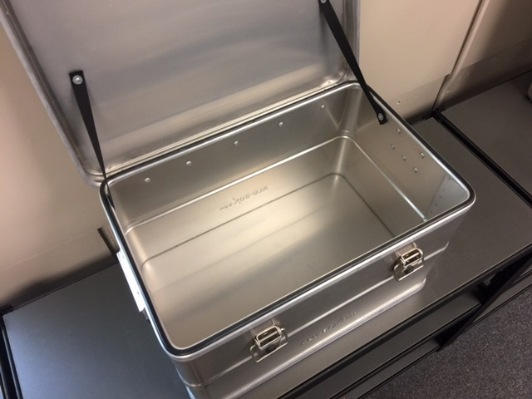
Food For 60 Liter Alubox
Soup
Chilli
Shells & Cheese
Knorr side dishes
Top Ramen
Oatmeal
Cereal
Bean dip
Kind bars
Licorice
Dave’s Killer Bread, 21 Grain
Blue chips
Olive oil spray

