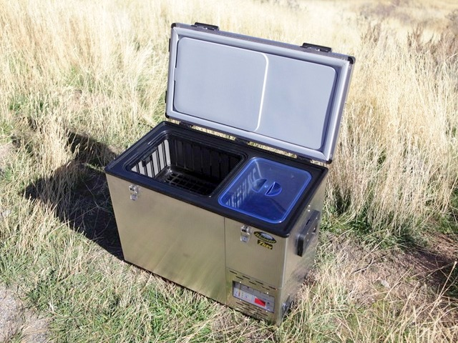
Food For Fridge & Freezer
Fridge Section:
Root beer
Pom tea drinks
Orange juice singles
Butter
Coffee beans & pre ground
Nuts, cashews, smoked almonds, etc
Tomatoes
Avocados
Salsa
Eggs
Cheese: sticks and shredded
Sour cream
Guacamole
Maple syrup
Freezer Section:
Maple breakfast sausage
Tofurkey dinner sausages
Garden Burgers
Ice cream bars

