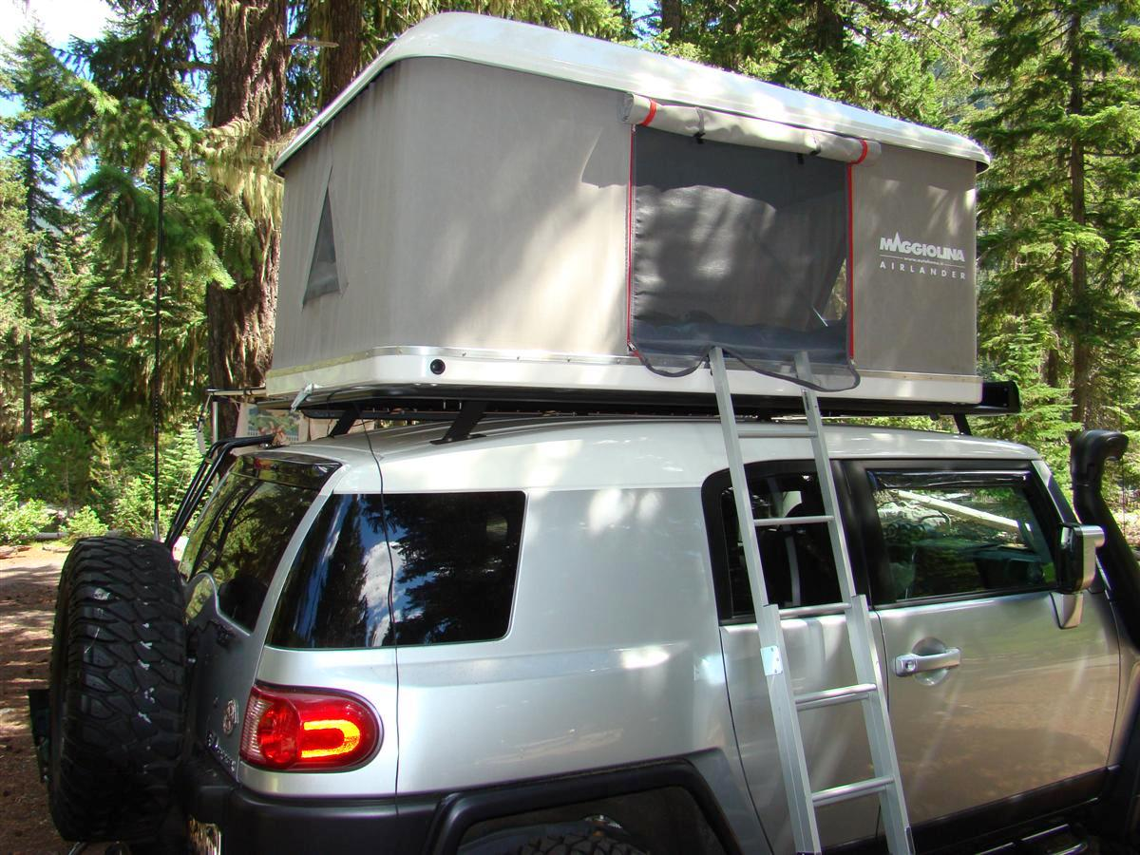
Camping List For Inside Of Rig
Food for fridge and freezer
Chuckbox
Three Aluboxes
Eezi-Awn K9 tables
Renogy solar panel
Katanaboy
Shower and gray bucket
Camping chairs
Lantern pole
Canopy
Duffle bag
Camera backpack
Pett toilet
ArkPak
Campfire In A Can
Burn logs
Drinking water
Glock pistols and small gun bag
First aid tacklebox
Black tube with ladder mat
Camping journal
Shower tent
Toiletries kit

